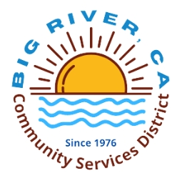

15-day notice

January 30, 2026

Big River Community Services District has an opening for a board member.

We have one applicant applying his name is Jim Hoover.

If interested contact:

Big River CSD at (760) 665 8454
E:mail: bigrivercsd@outlook.com

